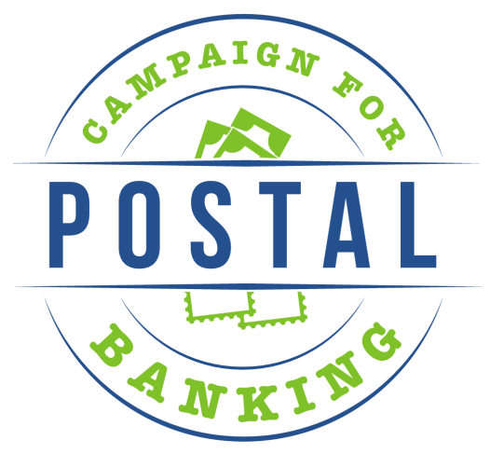

Resolution in Support of Affordable,
Consumer-Driven Financial Services at the Post Office

Whereas, there is a great need for affordable and accessible financial services, as an astounding one in four households (27.7%) is at least partially outside the financial mainstream, or underserved by traditional banks, according to a 2013 survey by the Federal Deposit Insurance Corporation; and

Whereas “legal loan sharks” prey on the underserved by trapping them in a cycle of payday loans, check-cashing fees, and interest that costs families an average of $2400 per year when their entire annual family incomes average just $25,000; and

Whereas, access to financial services is key to ensuring economic and social opportunity for low-income Americans, a vital priority at a time of growing inequality in our nation; and

Whereas, large banks have closed branches in low-income communities (where the largest number of underserved Americans reside); and

Whereas, the U.S. Postal Service operates more than 33,000 retail locations nationwide, many of which are located in “bank deserts” (59 percent of post offices are in zip codes with either zero banks or only one bank branch); and

Whereas, the U.S. Postal Service has a mandate to serve all Americans, regardless of geography, at uniform price and quality; and has a skilled workforce which processed more than 378,000 money orders per day in 2014; therefore, the Postal Service has the infrastructure to provide the desperately-needed services;

Whereas, worldwide, 1.5 billion people receive some financial services through their postal service and the U.S. Post Office Department successfully offered financial services, including savings accounts, for more than 50 years from 1911-1967; and

Whereas, the Postal Service is consistently rated one of the most trusted institutions and enjoys a much higher level of confidence from the public than do banks and payday lenders; and

Whereas, the USPS Office of Inspector General asserts that the Postal Service can act now to provide consumers with affordable financial services, by expanding and enhancing services including money orders and international money transfers, and introducing new services such as check-cashing, bill pay, and no-fee ATMS, and can do so under current legal and regulatory authority; and

Whereas, providing these services would strengthen our national treasure, the public Postal Service, and could bring in $1.1 billion annually within the first five years;

Therefore, be it resolved, that [ORGANIZATION NAME] does hereby call on the U.S. Postal Service to expand and enhance existing services such as check cashing and international money transfers, and to take necessary steps towards designing and implementing additional financial services.

Campaign for Postal Banking ▪ 1300 L ST NW ▪ Washington, DC 20005
Tel: (202) 842-8589 ▪ www.campaignforpostalbanking.org

